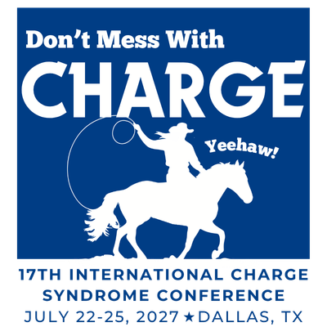
CHARGE Syndrome Foundation, Inc.

17th CHARGE Syndrome Conference
July 22 – 25, 2027, Dallas, TX

The CHARGE Syndrome Foundation, Inc. will be hosting its 17th CHARGE Syndrome Conference in Dallas, TX, July 22 – 25, 2027. This is the largest gathering in the world of individuals with CHARGE syndrome and their families. During the conference, we will be having a Silent Auction and Basket Raffle to raise funds for the Foundation. Donating companies will be promoted on our website, social media, and conference materials. We hope you will participate in this fun event by donating items for the auction.

If not bringing items to Conference, please ship to:
The CHARGE Syndrome Foundation
PO BOX 327
Girard KS 66743

Please ship items by July 1, 2025 to arrive in time to organize.

If bringing items to Conference, please drop off no later than 9:00 AM on Friday, July 23, 2027.

The CHARGE Syndrome Foundation is a 501(c)3 charitable organization (Tax Identification Number 43-1642150). The silent auction is a major fundraiser for the Foundation. Proceeds from the auction help offset the costs of the conference so that we can make this life-changing event accessible for many families. No donation is too large or too small.

CHARGE syndrome is a recognizable (genetic) pattern of birth defects, which occurs in about one in every 9,000 to 10,000 births worldwide. It is an extremely complex syndrome, involving extensive medical and physical difficulties that differ from child to child. The vast majority of the time, there is no history of CHARGE syndrome or any other similar conditions in the family. Babies with CHARGE syndrome are often born with life-threatening birth defects, including complex heart defects and breathing problems. They spend many months in the hospital and undergo many surgeries and other treatments. Swallowing and breathing problems make life difficult even when they come home. Most have hearing loss, vision loss and balance problems that delay their development and communication. All are likely to require medical and educational intervention for many years. Despite these seemingly insurmountable obstacles, children with CHARGE syndrome often far surpass their medical, physical, educational, and social expectations.

We very much hope that you will be part of this event. Thank you in advance for helping to make our Silent Auction/Basket Raffle a huge success.

Should you have any questions, please contact us at Conference@CHARGEsyndrome.org.

Very truly yours,

CHARGE Syndrome Foundation, Inc.

